

Dynamics 365 - Inventory shortage calculation batch job

Revision 1
Revision History

Date | Revision | Description | Signature / Date
30/09/2022 | 1 | Initial draft of user manual: Dynamics 365 - Inventory shortage calculation batch job | Prepared | Waseem Abbas
 |  |  | Verified
 |  |  | Approved
 |  |  | Prepared
 |  |  | Verified
 |  |  | Approved
 |  |  | Prepared

Table of Contents
1 About User Manual 5
1.1 Dashboard Overview 5
1.2 Production Orders 5
1.3 Two Ways to calculate the inventory shortage batch job 6
1.3.1 Approach 1: Direct Calculation of batch job 6
1.3.2 Approach 2: Step by Step Calculation of the production order 6

List of Figures
Figure 1. Processes in Dashboard 5
Figure 2 Production Order Flow 5
Figure 3 Direct Production Order Batch Job 6
Figure 4 Create Production order 6
Figure 5 Scheduling of the Production Order 7
Figure 6 Scheduling of the Production Order Pup up 7
Figure 7 Estimation of the Production Order 8
Figure 8 Release of the Production Order 8
Figure 9 End of the production Order 9

About User Manual
This document describes the step-by-step guide of manually creation of a batch job of a product or a list of sub-products (items). These batch jobs are, typically, created by a purchase agent (employee) in a legal entity (legal organization). The purchase agent creates and forwards the batch job to a vendor, who has been chosen (selected) for that product through purchase requisition bidding process.
The step-by-step guide of a batch job creation will be explained.

Dashboard Overview
After logging in, the you will see the main dashboard, which includes the grid of individual Workspaces (in the middle), which are represented in the Figure 1.
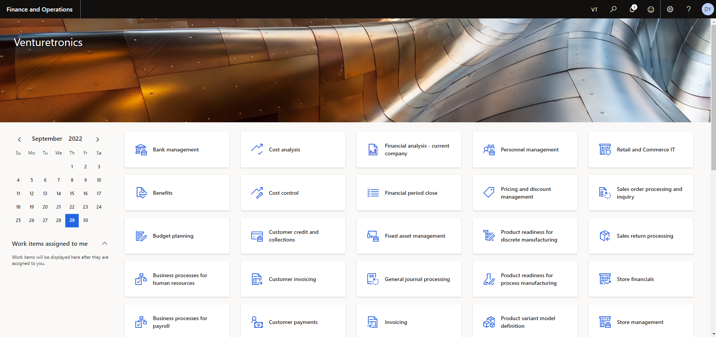
Figure 1. Processes in Dashboard

Production Orders
The users need to get production orders to perform his process. The user can get this by clicking on module then production to click on all production order. The process can understand by seeing the below Figure 2.
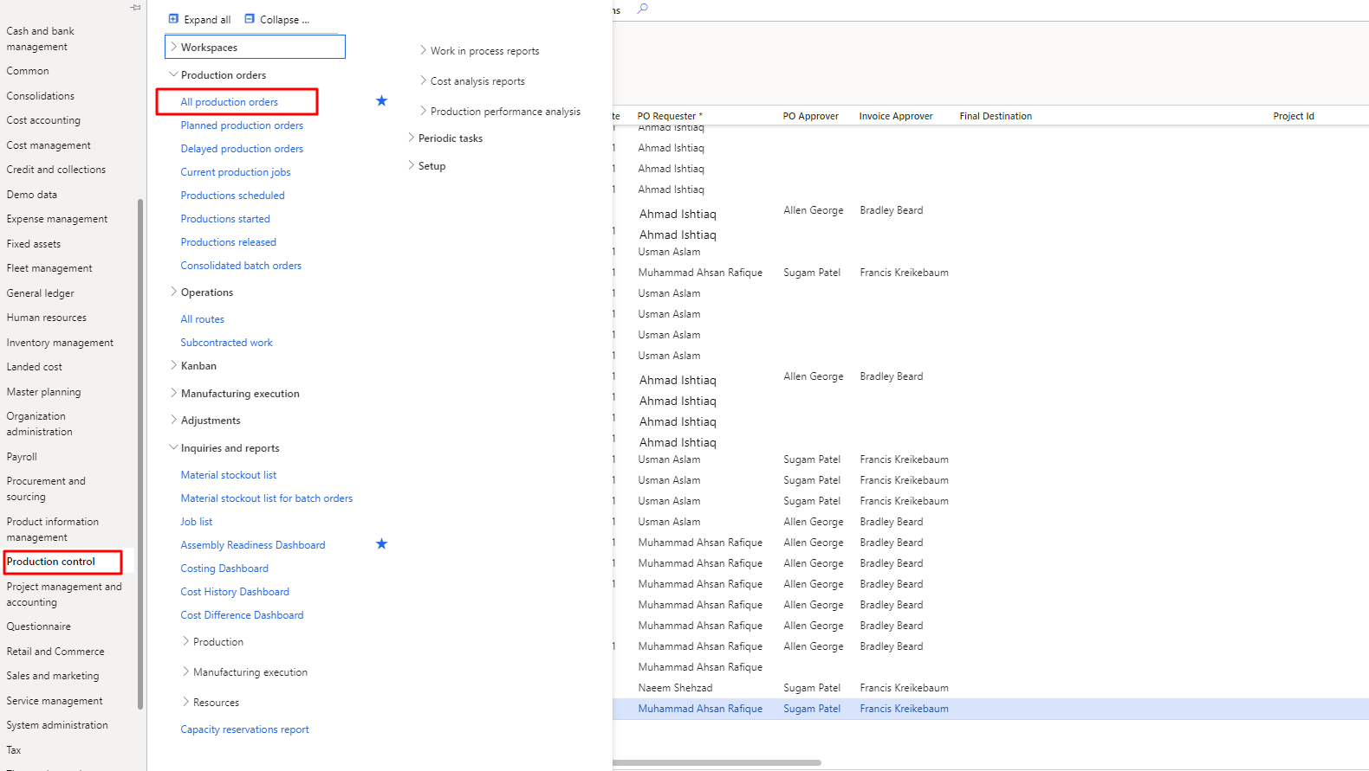
Figure 2 Production Order Flow

Two Ways to calculate the inventory shortage batch job
There are various ways to calculate the batch job.

Approach 1: Direct Calculation of batch job
If you want to calculate the directly calculation of the batch job, click on the “Calculate Purchase Order” tab (from purchase order). The user will be able to see the detail pop to calculate the shortage batch job. The need to fill the data as per requirement to calculate job then click on “OK” to submit the calculation. These inventory shortage calculation batch job processes are already highlighted in the Figure 3.
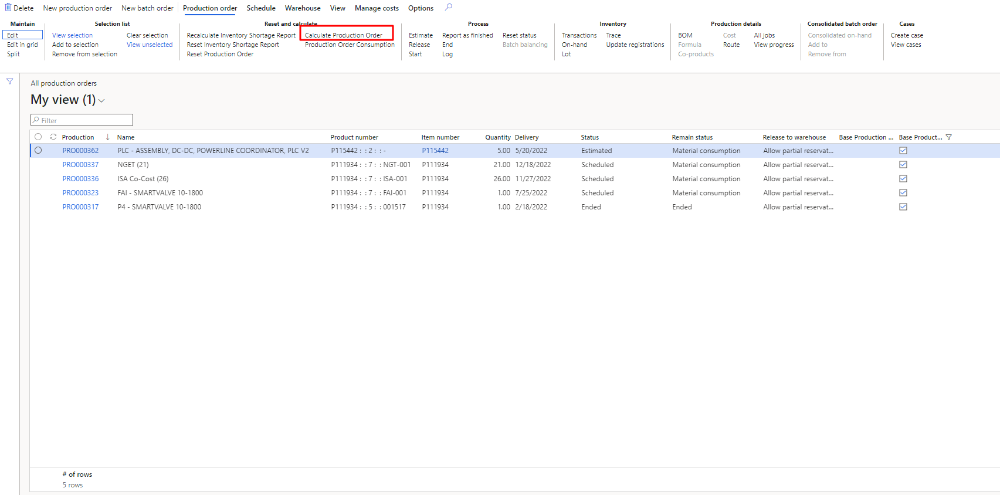
Figure 3 Direct Production Order Batch Job

Approach 2: Step by Step Calculation of the production order
The user can perform this process in step by step. We have following status/steps “Created”, “Estimated”, “Scheduling”, “Releasing”, “End”. The user has to access the production page to create the production order. The user needs to click on the “Create Production Order” to create any new production order. This process is already highlighted in the Figure 4
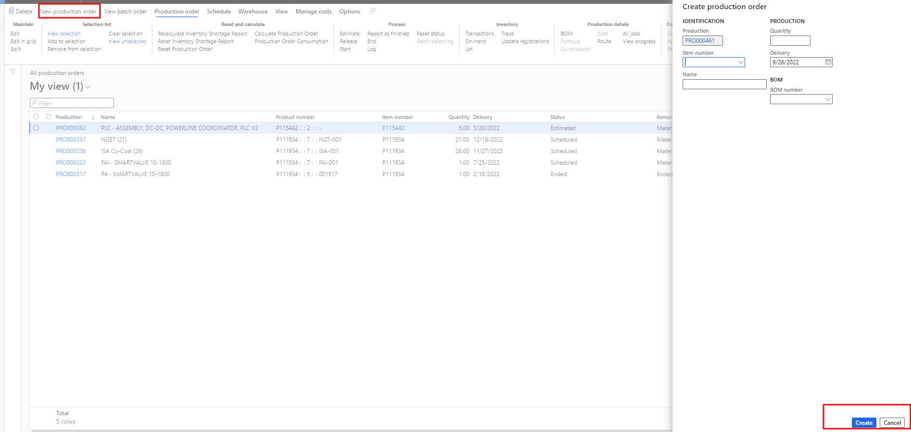
Figure 4 Create Production order

Scheduling of the Production Order
In step 3, the user needs to go “Schedule” then click on “Schedule Operations” to send the item. It will calculate the estimation of the product. As the user will click on it then need to fill update data on the popup form to calculate the estimation. This process is already highlighted in the Figure 5.
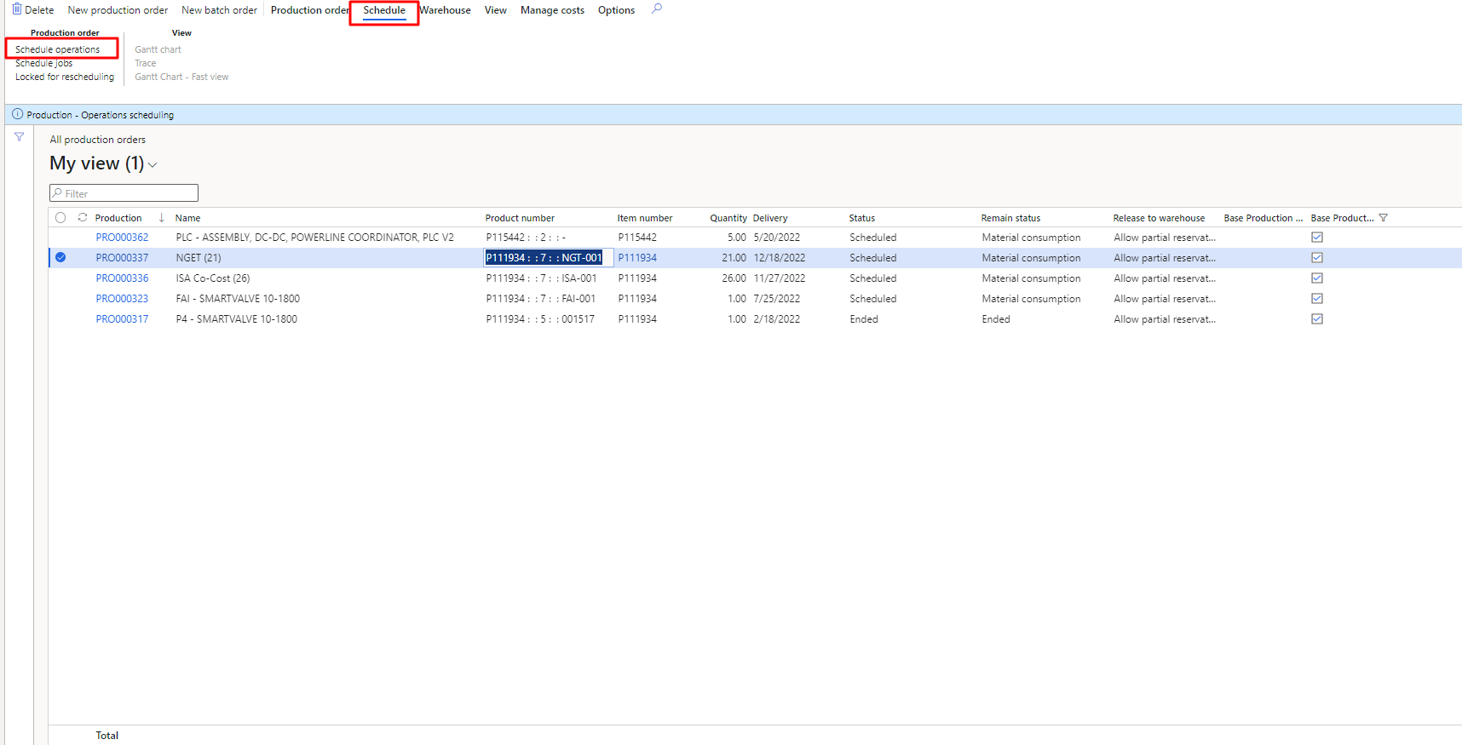
Figure 5 Scheduling of the Production Order
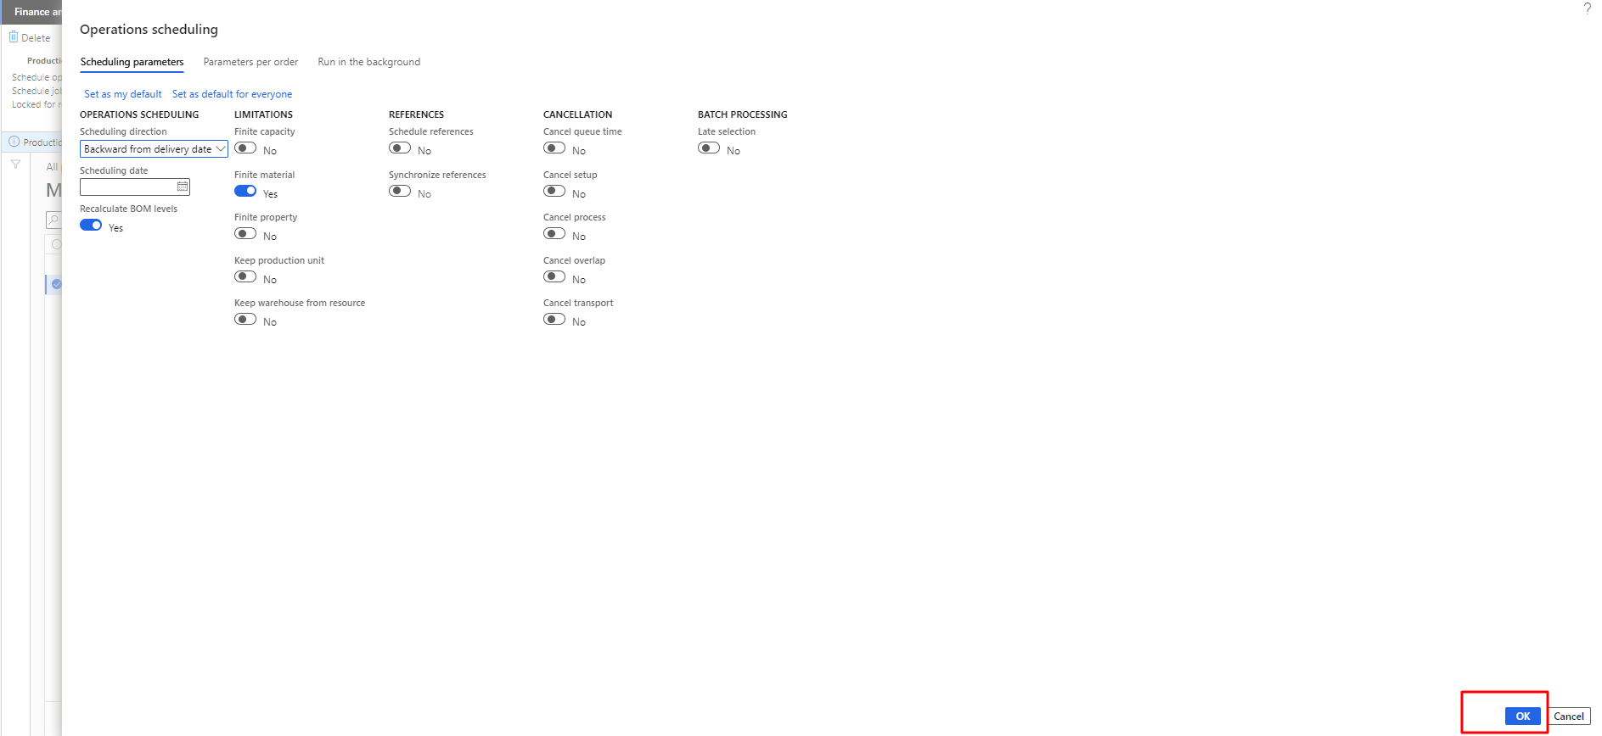
Figure 6 Scheduling of the Production Order Pup up

Estimation of the production order
In step 3, the user needs to go production order then click on “estimate” to calculate the estimation of the item. It will calculate the estimation of the product. As the user will click on it then need to fill update data on the popup form to calculate the estimation. This process is already highlighted in the Figure 7.

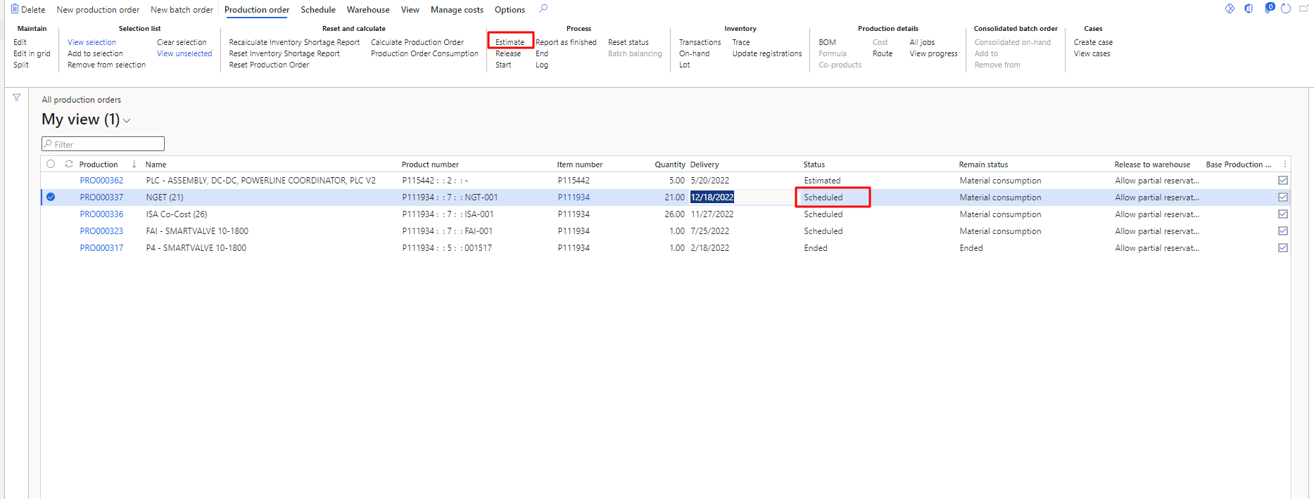
Figure 7 Estimation of the Production Order

Release of the production order
In step 4, the user needs to go production order then click on “release” to forward the item to release. It will forward the item to release. As the user will click on it then need to fill update data on the popup form to calculate the estimation. This process is already highlighted in the Figure 8.
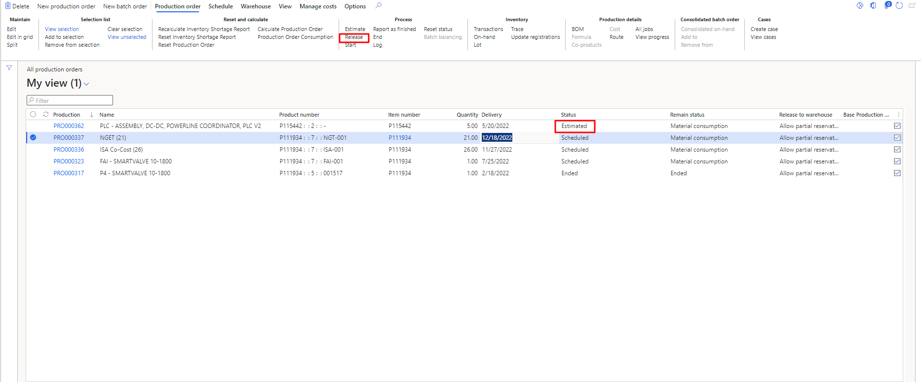
Figure 8 Release of the Production Order

End of the production order
In step 5, the user needs to go production order then click on “End” to do the item order end. It will ended the production order. As the user will click on it then need to fill update data on the popup form to calculate the estimation. This process is already highlighted in the Figure 9.
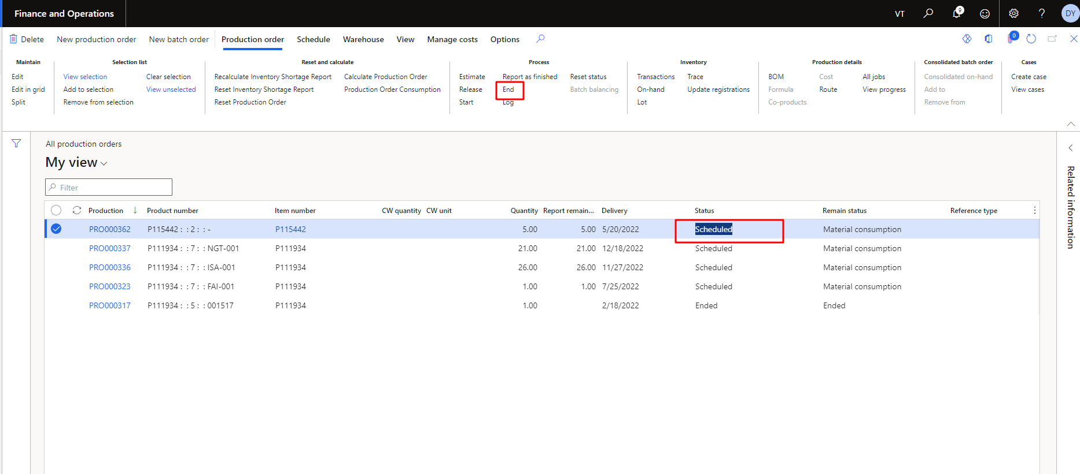
Figure 9 End of the production Order

